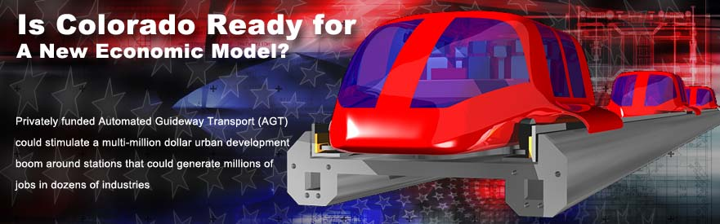

$10 million for a Colorado AGT (Automated Guideway Transport) CONSORTIUM that will build a Prototype track and a sponsor public vote on an $90 million operating demo as a rehearsal for a $1.5 billion route for I-70. Smartskyways is offering 10 founding memberships in a consortium for $1 million each to Joint Venture a specific part of the overall plan as shown in the following plan.

For their capital and services, the membership will divide 50% of all profits earned from future sales such as a 5mile demonstration route in the Platte Valley. Members will also get to participate in building future routes. The following business plan illustrates how annual profits (before taxes) are attainable in sponsoring this Platte Valley operating demo. We believe $90 million will qualify for tax free revenue bonds to build it. Over 10 years the Consortium could sponsor many profitable routes the same way such as a $1.5 Billion route for I-70 and then a $2 billion I-25 route. Both of these could generate up to $1.5 billion in 20 local loops along these Interstate routes.

1.0
We are organizing a Colorado AGT Development Consortium to collaborate with us on engineering and building a Prototype track and lab. The Consortium will configure the prototype technology set, financing and management that markets our Automated Guideway Transport (AGT) in Colorado for voter approval of various routes. These routes will be privately owned Franchises seeking public approvals for using Public Rights of Ways. The Consortium will market $10 Million (min.) in memberships to companies (see 5.6) that want to build routes and participate in the management of each venture. The first proposed venture is $90 million tax free bond for 5 mile operating demonstration loop in Denver’s Platte Valley. We are illustrating the following membership benefits in this business plan:
1. Capital is returned from cash flow from $90 million Operating demo estimated at $2 million p/y
2. Potential Profit in 10 yrs estimated at $28 million (before taxes) for 50% share.
3. Return On First Sale is potentially $2 million per year for 50% share
4. Long Term Potential Sales in Colorado could exceed $5 Billion forecast (see 5.6)

1.1 Short Term Objectives
The short term objective is to get in business by raising $10 million for building a Prototype track to market our Smartskyways technology for public approval of a privately funded, engineered, built and operated Franchise route such as proposed in the Platte Valley. This approval gives us a potential multi billion dollar sales market and positions us to build a 5-mile operating demo in the Platte Valley of Denver or elsewhere.

1.2 Long Term Mission
To markets transportation solutions, technical specifications, financing and organizational work for automated guideway transport (AGT) as a viable investment for the private sector, government enterprises and large landowners.

2.0 Smartskyways Company Intro
A dozen companies and individuals have collaborated for 8 years to research transit operations world wide and integrate what was learned into conceptual specifications for an automated guideway transport that is inexpensive to build, driverless (to save operating cost), operates on demand (to attract riders) and based on auto technology (for familiarity). We will sell specifications and organizational work for operating royalties to malls, campuses, resorts, office parks, airports, downtowns, cruise ports, sports arenas and other areas of congestion worldwide. Our specifications are engineered configurations of interchangeable, modular parts similar to the erector sets we played with as children. Our expected share of other future ventures will come from a 3% to5% royalty charged on the gross operating revenues. The various members of the management team will share a collective 70% of the Platte Valley profits.

We have an engineering dream team that has done most of Disney's transport, the MGM Las Vegas Monorail, Portland light rail, Durango Silverton RR and numerous other projects. Our administrators have experience as chairman of Denver RTD, financial packaging and tax district creation and management. We have established relationships with consulting firms that have financed designed and built almost anything. Lloyd Goff has 35 years experience in packaging real estate development ventures for others.

2.1 Smartskyways Ownership
This is composed of ownership in SmartSkyways Inc between engineers and administrators and who are allocated 50% each.  Administrators & Founders:  Lloyd Goff - 20%  Mike Barrett - 10 %  Norm McIntosh - 05%  Bill Rourke - 2.5%  Staff - 2.5%  Investor -10.0% _ .  50% |  |  | 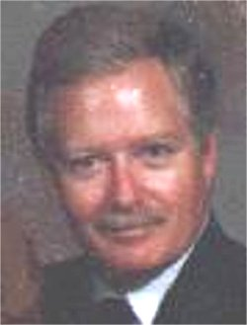  Goff |  |  | 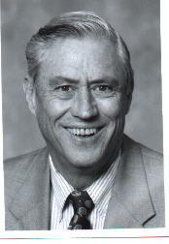  Barrett
 |  |  | 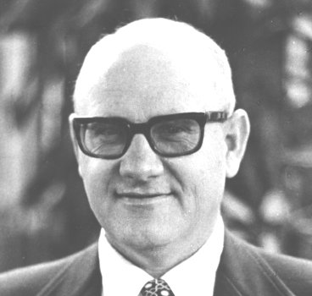  McIntosh |  |  | 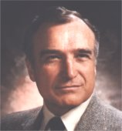  Rourke
Engineers  Kent Bingham  Bob Hamilton  Don Sullivan  Others .  50% | 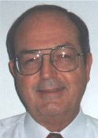  Bingham |  |  | 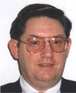  Sullivan | 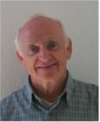  Hamilton
2.2 Smartskyways Consulting Relationships
Grimshaw and Harring has worked on the project since the beginning and will handle all the legal work for creating districts to sponsor and fund routes. They have brought in Kirpatrick Pettis Investment Bankers to advise Smartskyways on financial structures, due diligence and money management. Mike Schlueter is the Corporate Attorney and has completed the conversion from the LLC format of the past 6 years to a new corporation (Inc). Martin and Martin engineers have participated for more than 5 years and will work on the civil engineering aspects of alignment, infrastructure surveys, superstructure, soils and footings. Agreements are in progress. On the web site, Tracey White has done the technical conceptual illustrations, Scott Miawald did the front-end graphical interfaces and Cliff Dolan designed and operates the web site.

2.3 Smartskyways Personnel Plan
The basic team will require $60,000 per month to set up, administrate and market the venture contemplated in this plan. In addition there are budget items that will earn addition compensation to team members such as in engineering.

Name Job Description
Lloyd Goff President
Mike Barrett Civil & Approvals
Norm McIntosh Community Affairs
Bill Rourke Press Relations
Cliff Dolan Info technology
Tracey White Illustrator
Kent Bingham Head Engineer
Bob Hamilton Track Operator
Don Sullivan Quality Control
Total Headcount 9

2.3 Smartskyways Proposed Product Line
We have an engineering dream team that has done most of Disney's transport, the MGM Las Vegas Monorail, Portland light rail, Durango Silverton RR and numerous other projects. Our administrators have experience as chairman of Denver RTD, financial packaging and tax district creation and management. We have established relationships with consulting firms that have financed designed and built almost anything. Lloyd Goff founded and managed the Platte Valley Landowners Association from 1983 until 1995 and knows this redevelopment district well.

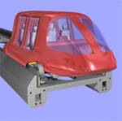 | Skyways at $10 million per mile  DESIGNED for metro and neighborhood circulators, 4 to 6 passengers, 40 mph to 80 mph. on tires
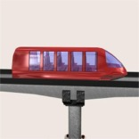 | Skyrail at $12 million per mile  Designed Dual mode integration with existing rail-lines for cross country at lower traffic density, 15 passengers, 80-mph to 120 mph on steel wheel and switches on the fly to rubber tire in town
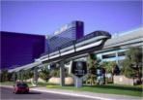 | Monorail at $35 million per mile  BUILT for highest traffic corridors under 20 miles with 50 to 100 passengers at 30 mph
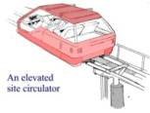 | SkyHawk at $5 million per mile  Designed for large sites linking parking, buildings and stations, 4 passengers, 10 to 25 mph on tires
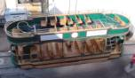 | Trolleys at $ 4 million per mile  BUILT for retail, resort and attractions circulation 60 passengers, 8 to10 mph on steel rail
2.4 Description of Prototype
S.M.A.R.T. stands for Switchable, Modular, Automated, Robotic and Telematic. This is an elevated guideway system that goes above the existing traffic. It has passive switching, which allows for off-line docking and no stop service to your destination like the Interstates. The guideway is precast in modular sections that are cheaper to build. It only supports the weight of a family car up to a limousine and this allows for it to be much smaller and cheaper. Automation allows for driverless 6 and 15 passenger cars that start, merge, switch, slow and stop for robotic loading. Drivers are the majority of transit costs and eliminating them allows the farebox to be self-supporting and grow profits over time. Each seat can be Telematic with touch screen WIFI Internet connections for travel information and reservations of what is along the route.

3.0 Consortium Start-up Summary
Our Start up costs are estimated at $10 million to organize and mobilize a new company that engineers and builds a Prototype track/lab and uses it for selling future routes. This covers $2 million for engineering and building a Prototype track with mock up of cabins. There is also $ 2 million for marketing the public approval of a tax free bond to build a 5 mile demonstration model. An additional $2 Million is reserved for working capital

3.1 Consortium Capital Required -$10 million
Smartskyways Inc is seeking $10 million capital contributions payable in over 2 years as equity to build the non revenue functions of the business. The first project will be to built a revenues generating operating system that demonstrates ridership and farebox potential. Smartskyways has engaged Kirpatrick Pettis as Investment Bankers to collaborate of a tax free revenue Bond with these proposed Terms: Interest at 6% with payments for first 3 years of operations from a reserve included in loan. Years 4 to 10 include 6% payable interest plus amortization at a 30 year rate, ballooning in 10 years. The investor will provide a disbursement plan for construction. These funds will be used for:
3.2 Consortium Start Up Budget
Set Up Company and Advisory Board | Mobilization $50,000
Admin, Staff, legal, CPA, Docs & broker fees | Mobilization $500,000
Economic Feasibility Modeling | Mobilization $150,000
Overhead 12 Mos |  | Mobilization $50,000
Civil, soils, alignment and grounds prep |  | Mobilization $250,000
Design Engineering, Construction Bids | Prototype Track $1,800,000
Build 1/4 mile Prototype Track with 6 switches | Prototype Track $500,000
Automation Command and Control | Prototype Track $700,000
Power Distribution | Prototype Track $250,000
Stations, maint bays fuel depot, operations | Prototype Track $500,000
Build 5 chassis with propulsion, switches | Prototype Track $400,000
Mock up 6 and 15 passenger cabs | Prototype Track $275,000
Multi Media Tools/ Marketing (Public and Investors) | Marketing $750,000
Build Scaled Model ( Kits) and video | Marketing $150,000
Campaign for Public Vote | Marketing $1,100,000
Working Capital and Reserves | $2,000,000
TOTAL CAPITAL | $10,000,000

3.3 Consortium R&D Track
This is a ¼ mile circular single lane guideway about the size and shape of a high school running track. It development will prove two of the three critical factors in the feasibility of AGT: the cost of construction and the costs of operating a system. The final factor of revenues will have to wait for an real operating system with paying farebox. This proof of technology model will be used for marketing additional funding and to win a public vote for future routes.. Use of Funds is for:
Elevated Guideway Costs
3 chassis ( stripped down vans)
3 electric golf carts
maintenance bays and shop
control and sales trailer
electric generator and distribution
pubic station and ramps automation command and control
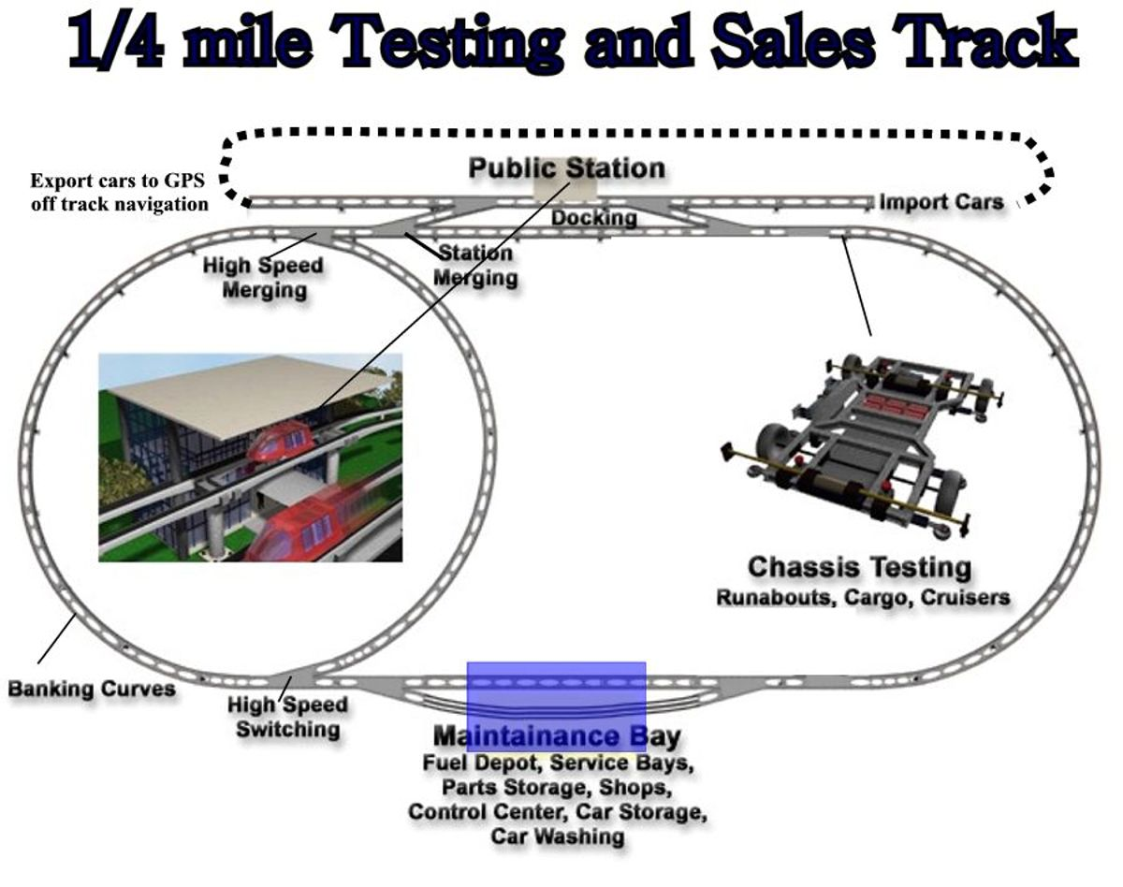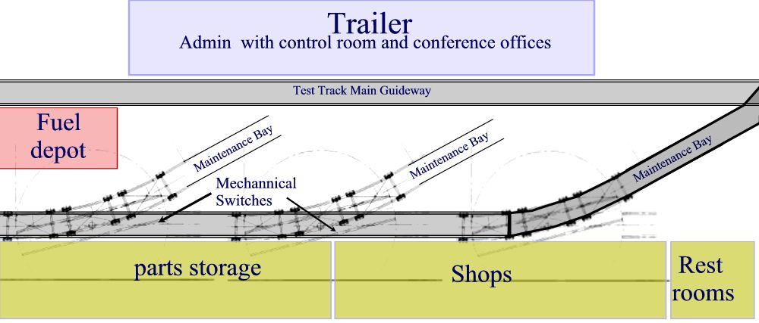
Maintenance Yard 40’ x 80’

3.4 Possible locations North of Prospect Sub Area in Platte Valley
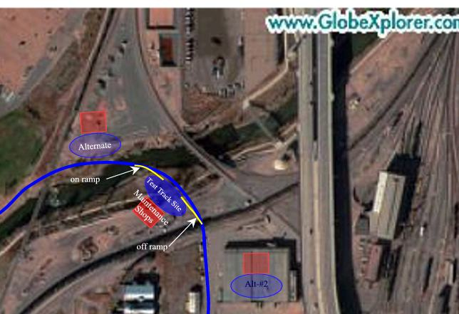

3.5 Consortium Prototyping
The expected results are specifications for starting, safety systems, stopping speed, merging and switching controls for a 5 mile operating demo with passengers in the next phase. Testing will be at 30mph resulting in 44’ per second design criteria for curves, switching, ramps and power. The Prototype track will provide an environment suitable for the evaluation of various software using a packetized concept which divides the ¼ mile (1320’) track into 100 packets of 13.2 feet which is also the length of each chassis. Testing will include command and control instrumentation configurations such as Global Satellite Positioning systems, buried cable and WIFI (wireless system). Propulsion is provided by Rotary 100 hp electric motor as used in golf carts, but more powerful. Lineal Induction Motors may be experimented with as funds allow. Power Distribution will be evaluated between mechanical (sliding contact) and induction (no physical contacting surfaces). An electric generator that runs on a TBD fuel source such as hydrogen (with the power grid as back up) may provide the required propulsion and other onboard energy . A mock up of the 6 and 15 passenger cabins will be included as funds allow. This could include a full seating and space buck mock-up with seating, dashboards, HVAC, lighting, seat screens, interior trims, windows and doors all with wireless controls and a dashboard CPU control.

3.6 Consortium Target Members
In addition to a basic investor group, this venture will leverage the available expertise by taking on suppliers, venders and even future customers who want to help build future routes. Every member will bring a selected type of expertise to the consortium for which they will be made into a participant in building and operating future routes.
Propulsion Systems | Credit Cards processing | Voter Campaigns
Travel Reservations | Cargo Integration | Vehicle Assembly
Automation System | Station Development | Underwriting Docs
Power Distribution | Raw Concrete & Steel | Money Management
Guideway Fabrication | Seat Laptop Advertising | Station Car Rentals
Economic Feasibility | Construction Management | Airline Handoffs

- Market Analysis Summary  Demand for transport is the 4th largest industry in America topping one trillion dollars for auto, rail, bus, boat and plane transportation. Household spending averages over $8,000 per year. Demand for mobility is growing at twice the rate of the population growth causing cities and suburbs to become even more crowded. The growing congestion is creating a demand for new solutions to relieve airports, rail and highways from near gridlock. In the next 40 years population is expected to double in cities everywhere. | 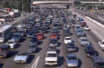  Congestion is growing everywhere
An even more ominous problem is that we are running out of cheap oil and the demand is going to drive the prices up to double what they are today in the next 10 years. An all electric network that shares cares, does not pollute and goes into low density areas is sure to find strong acceptance.

4.1 Market Segmentation
Our products are aimed at the elderly, students, military, travelers, event and commuters with competitive pricing to owning or even operating a car. Our products are similar to a car or limo in size and can go into neighborhoods to pick up and deliver users within walking distance of their door without needing a car. Hourly car rentals will be available at many stations.

Segmentation
1. Those willing to temporarily give up their car in congested local areas
2. Those willing to permanently give up their car in Metro areas
3. Those willing to substitute a higher priced car rental for lower priced shared car
Market Pricing
1. Neighborhoods |  | $30 per/mo |  | Unlimited use |  | $2 walkup use p/d
2. Regional |  | 15c-20c p mile |  | Reservations

4.2 Target Market Segment Strategy
The target market of the Platte Valley loop is the commuter and daily business people that drive to work. Cheaper parking will attract ridership and by offering on demand service, elevated above the traffic and low monthly subscription rates that saves the consumer money enough ridership is possible to provides predictable revenue to operators. Parking in most downtowns is in high demand and growing expensive. In downtown Denver rates are $10 to $15 per day.

4.3 AGT Industry Analysis
The AGT industry is a start up infrastructure for automating anything that moves, including people, cargo, mail and trash. It has many similarities to the Internet infrastructure and is now about where the Internet was 8 years ago. This industry is ready to explode all over America with small start up venders marketing a web of routes that can be integrated with airports, highways and rail to the benefit of all. Unlike the Internet these investments will not go puff and disappear because they are hardware serving in markets that will grow in demand. AGT can serve as an extension of coverage for light rail by collecting and distributing passengers to/from their door.

4.4 Competition
The existing competition is mainly from light rail which is a government funded program that is growing more difficult to get funds. Rail is limited to only highway corridors where Rights-of-Way can be easily obtained. This causes users to need a car to drive to light rail instead of it coming to them. Light rail is attracting a small percentage of the potential riders because it doesn’t do to their door. In addition, the federal government is the only funder of these systems causing intense competition for very limited funds. Over 100 cities are competing for limited funds. The funds will only get smaller in the near future as government deficits rise. AGT will be competitive if it can privatizing the financing and serve the low density market of the final destination for door to door service.

4.5 Competitive Edge
Politically, we have a great story to tell and have carefully crafted it into a variety of digitized media that can explain Skyways to the public. We will compete with existing transit by offering our door to door circulators at $10 million per mile as our main product to collect and distribute for rail as AGT is able to go anywhere that others can not, into the neighborhoods for our ridership. We will compete with newer forms of transport by offering turn key solutions including organizational work and private sector financing such as landowner initiated “Districts” or local community Enterprises that sponsor routes.

5.0 Sales Implementation Strategy
The most important milestone is to build a $10 mil. Prototype and sales track that proves both the feasibility of the automation technology and it’s low construction costs at $10 million per mile. Once a Prototype track is operational, it can be used to win public approval for building an operating demo with real fare paying riders. Once we prove the revenues potential from an operating demo combined with the low operating cost that result from automation , then we are ready for future sales.
5.1 Marketing- $1,200,000 will be allocated to wage a vigorous campaign for the public to approve the concept of “Operating Franchises” within the State of Colorado. The authority to operate any subsequently publicly approved route, will be the basis for raising private capital to build various route. The issue we want to raise with the media is " DO YOU FAVOR PRIVATIZING SOME TRANSIT" ROUTES ? The campaign will use a variety of media to direct attention to our web site where our story can be told very effectively: bumper stickers-yard signs -postcards -posters-fax- email-CD-ROM- Video tape-talk shows-PR placed News. We will maintain a VOTE button on the homepage demonstrates how we plan to capture public consensus and show it to the governing bodies of the routes we want to pursue.
  - Sales Strategy
After winning a public vote on Franchising, our sales strategy is to build an operating sales demo and then show buyers how it can attract enough revenues to earn a profit. Our customers will be local business communities, malls, hospitals, airports, universities and resorts. Then we grow the sale from a mobilization fee for engineering and organizational work to a ¼ mile Configuration track that will become the future maintenance and vehicle storage for a small 5 mile local loop. During the mobilization phase our turnkey services will include assisting the buyer with route feasibility, engineering, financing and bidding, In the next phase we will add building supervision and operations. We will take our sales profits from a long term 3% royalty on operating revenues instead up front.

  - Proposed Platte Valley Route
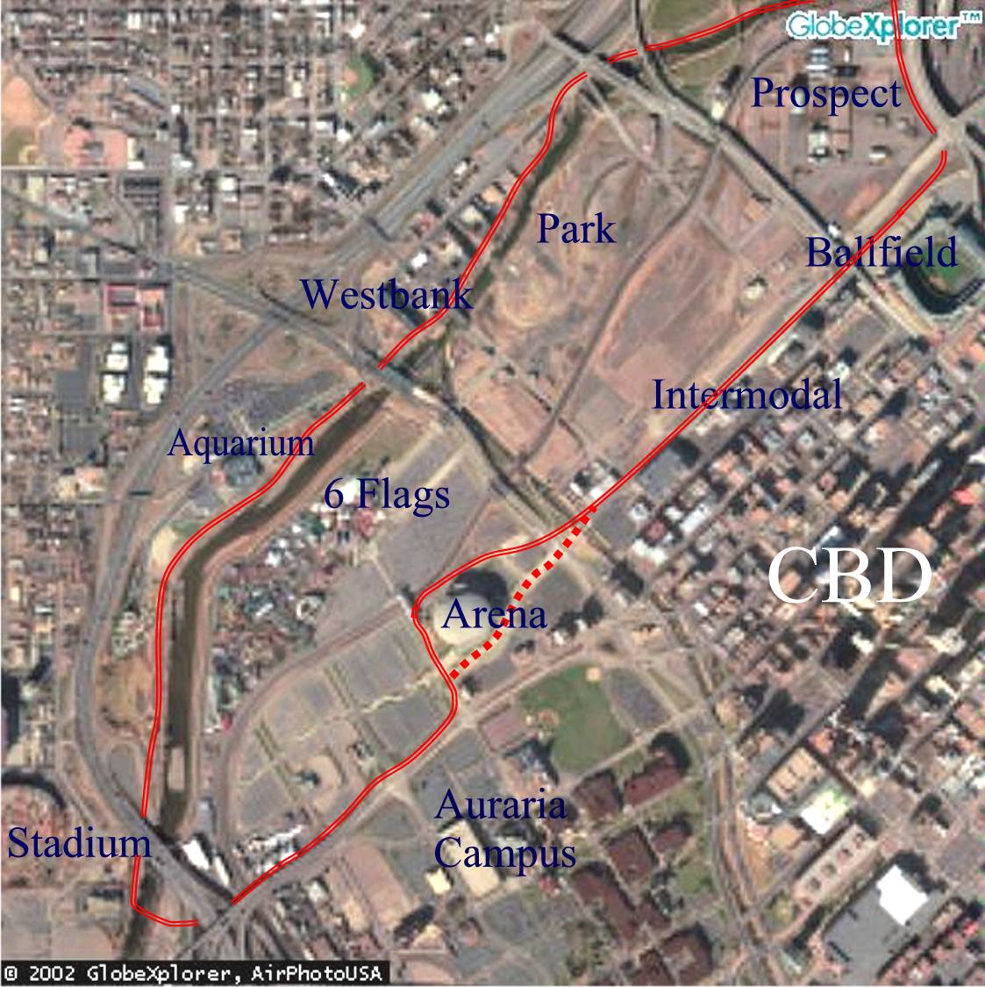
Platte Valley 5 mile operating demonstration with 22,000 passengers per day possible

5.4 Closing The Sale with a Ballot Approval
Because transportation affects everyone, it must be collaboration between the local government, property owners, sponsors and vendors. We will offer choices in how to set up the ownership and governance. Choice # 1 is a private Franchise in which the profits are distributed to the investment partners who build the system and operate it. The railroad and airplane industries were both built this way. These profits are distributed annually as summarized in 3.4

Choice #2 is a Government Enterprise such as an RTA (Rural Transportation Authority) in Colorado in which all the same parties get together for the same purposes, but the profits are kept in the authority for expansion or other public Purposes. The RTA has broader powers. We also see the RTA as the buyout for the private investors when they want out. wants.

6.1 Platte Valley Economic Analysis
We feel the Platte Valley offers the best location for a demonstration site, if we can get increased revenues from linking 30,000 existing parking spaces to downtown’s 44,241 spaces as a day time parking reservoir. These spaces are mostly empty during the day because they were designed for sporting and entertainment venues. At $3p/space p/day we would attract a bigger ridership and be priced significantly less than downtown’s $10. The venues that control this parking would see a majority share net of these revenues as a windfall. This 5 mile loop will charge a modest $1 p/d for unlimited ridership and also bring the downtown workforce of 120,000 into the valley for entertainment, food and recreation.

We project 22,000 daily riders from many sources including 117,000 commuters needing parking 12000, RTD rail and bus transfers 3000, Hotel based tourists 1000, local residents 1000, events 3000 and CBD 180,000 daily business visitors 2000. Over 25 years developers will build millions of square footage served by these stations and the ridership will increase by 3.5% per year as will inflation. Compared against a fixed cost installation and 3% annual replacement cost, the revenue base over time will out strip costs and profits will soar as illustrated in the graphic below.

6.0 Potential ROI On First Sales-  The Platte Valley loop has the most revenue potential because of a share in the parking revenues. Smartskyways estimates the Platte Valley demo will earn from 10% to 20% return on investment for the Consortium members.  On future sales, the company makes money from a 3% operating royalties paid annually. We have 5 examples on web site and here is one of them shown right that illustrate the magnitude of the long term earnings potential. Consortium members will split 50% of the earning shown right. | Within 5 years Annual Royalty  Platte Valley $4,060,000  I-70 3%royalty $6,600,000

6.2 Platte Valley Budget for 5 mile Operating Demo
[in $1,000s]
COSTS Per Mile Unit 5 Miles
Engineering at 7.6% of Construction 1,750 job $8,750
Conc. Guideway beams fabricated 1,000 mile $5,000
Steel Roadbed track 500 mile $2,500
105 Columns & footings at $8800 924 mile $4,620
105 cross beams every 50' at $4300 ea 452 mile $2,258
Shipping to Job Site 40 mile $200
Erection 253 mile $1,265
Electric Power Distribution 700 mile $3,500
Control Systems 1,700 job+ $8,500
Stations/(local circulators not incl) 1,700 stations $15,300
Maintenance Facilities 200 min $1,000
Vehicles assume 100 with 88 to start 1,360 each $6,800
Off site civil at 5% 800 $4,000
Contingency at 10% 1,600 $8,000
Subtotal Direct 12,979 $71,693

INDIRECT COSTS
Administration (5.43% project cost) 792 $3,893
Underwriting Fees at 2% 437 $2,000
Reserves at 12.4% 2,188 $10,905
Subtotal Direct and Indirect 3,417 $16,798
TOTAL COSTS 16,396 $88,490

7.0 Forecasting Colorado Sales
We will organize local franchises or BID financing in communities linked by the Interstate that want to buy our specifications and organizational work. Our profit comes from a 25 year 3% operating royalty.

Routes |  | Millions | Year
Platte Valley |  | $88 | 2005
I-70 Route |  | $1.500 | 2006
DTC 5 mile route |  | $55 | 2007
Denver Internat. Airport |  | $60 | 2008
Interstate 25 |  | 2,000 | 2009
Denver Loops |  | $700 | 2010
Vail |  | $30 | 2011
Keystone |  | $35 | 2011
Breckenridge |  | $35 | 2011
Dillon/Silverthorne |  | $40 | 2011
Gaming Towns |  | $40 | 2012
Boulder |  | $50 | 2013
 | Frisco | $20 | 2014
Colo. Springs $100 2012
Fort Collins $45 2013 Pueblo $30 2014 Total $5,000

7.1 Sales in Other States
We are currently studying 10 states where we think a $100 million demonstration model has the right fit to be economically successful. This map shows them on our web site as ROUTES (a button on the home page). Each route will be packaged over time into a development venture. Only 5 studies are in progress.

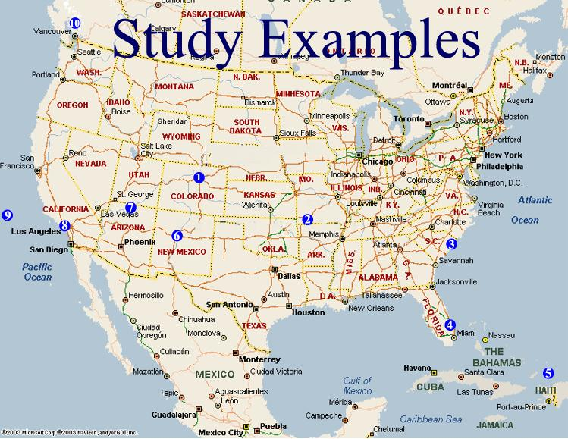

8.0 Risk Analysis
Once a $5 million Prototype track is built, sales can occur anywhere. The Prototype track will remove the majority of risk be proving the development costs and automation operations. This leaves ridership as the largest remaining unknown. The next big area of risk is “Project Creep”. This occurs when government insists on adding things not originally in the budget. An example of this occurred in Seattle when local government insisted that cat walks be added to a guideway for public safety in case a vehicle broke down; they wanted the passengers to be able to walk way from the vehicle. This can be addressed in the ballot by approving a safety plan along.

8.1 Critical and Important Assumptions
1. Low construction and operating costs are capable of earning attractive profits
2. Automation will reduce operating costs to less than 30% of gross
3. Low fares with unlimited ridership and conveniences will attract sufficient riders
4. Travel demand will increase causing oil issue, pollution, congestion to continue to get worse
5. Real estate development around stations will increase ridership and attract partners

8.2 Milestones | Start Date | End Date | Budget | Manager | Department
Seed Capital | 6/1/2004 | 12/1/2004 | $5 mil | team | administration
Set Up Company | 11/1/2004 | 3/1/2005 | 100,000 | Goff | Business manager
Engineering | 12/1/2004 | 5/1/2005 | $1,.800,000 | Bingham | Engineering
Start Prototype Track | 5/1/2005 | 11/1/2005 | $4,000,000 | Barrett | Engineering
Public Approval | 6/1/2005 | 11/7/2005 | $1,200,000 | team | Administration
Development Consortia | 12/1/2004 | 12/1/2005 | $90 mil | Goff | Business Manager
Build operating demo | 1/1/2006 | 12/1/2006 | $70 mil | Bingham | Engineering
Operate for sales | 6/1/2007 | continuous | ? | Hamilton | Operations

9.0 Spin Offs- Like Real Estate Investment Multiplier Around Stations

Many new developments will want to integrate stations with mixed uses built around AGT access. In the city, a typical 2-block walk radius of 850’ can serve a land area over 2 million s.f. At 2 x1 density this represents more than 4.0 million s.f. of new development potential around a station stop. At $150 psf a station stop could impact hundreds of millions in future investment for condos, retail, restaurants and offices.
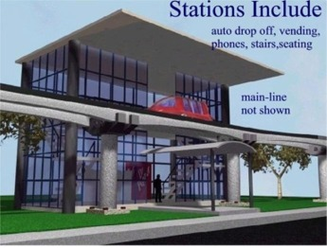
Possibly the most money to be made, will come from the new real estate development that occurs around the stations. Back east this multiplier effect is about 10 to 1 for every dollar invested in transport. In the Platte Valley demonstration, stations can grow into pedestrian villages with a mix of uses for offices, hotels and condos that likely will grow around the public station as shown here. There are 2.2 million sq. ft. of land around a station within 850’ walk. At left is a Public Station shown before development occurs.

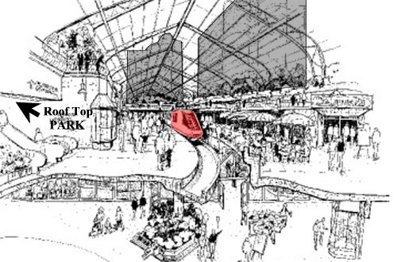 | 9.1 Private Stations  Many new developments will want to integrate stations with mixed uses built around supporting retail as shown in this example here. A typical 2-block walk radius of 850’ can serve a land area over 2 million s.f. At 2 x1 density this represents more than 4.0 million s.f. of development potential around a station stop. At $150 psf a station stop could impact hundreds of $millions in future investment for condos, retail, restaurants and offices.

9.2 Travel Reservations $5 million
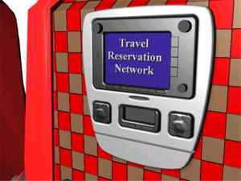
Each seat can have a touch screen computers with Internet access to show ads for lodging, restaurants, shopping and attractions along the route. With a marketing fee this could become a substantial revenue stream to the project. In fact with the right company involved in selling ads, it could become the travel reservations standard for the entire state. The stations will need kiosks selling boarding passes and these can be incorporated into the travel reservations system. A removable laptop computer located in the dash board will use WIFI (wireless) to operate each one. Some of this revenue has been included in the cash flow analysis just to draw attention to the possibilities.

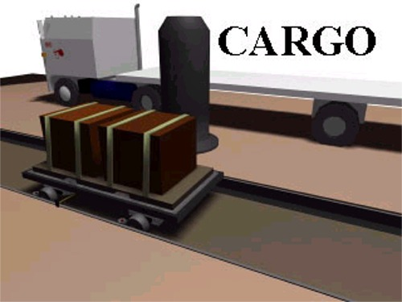
9.3 Cargo, Mail and Trash
A platform that holds containers can replace the passenger cabin on the chassis and deliver automated cargo including small packages such as Fed Ex to dedicated stations to further distribution to customers. This will operate mostly in the dark hours. As development around stations occurs, this can include mail, trash and even construction materials.

9.4 Selling Naming Rights to Vehicles-$5 to 25 million
Selling advertising space that has several forms of revenue generation is a novel way to raise financing. Examples include the big money deals for stadiums, arenas, billboards and the Internet, demonstrating there is a healthy market that believes in this type of advertising. This revenue would be for Exclusive Ads inside and outside car. This could be an annual fee such as $25,000 or a one-time payment that includes exclusive rights to these advertising spaces for 25 years. This includes signage, printed materials and a spot to advertise on the wireless travel reservations. An alternative would be to sell the cars and use the funds to reduce principle. This idea could also include depreciation for cars. The 5 mile operating demo would start with about 100 small runabouts and 100 large “Cruisers”. Theaters could buy a 15 passenger “Cruisers” to go out and collect its customers.

9.5 Web site $5 million
The current web site has over one thousand pages of information and thousands of hyperlinks to news, ballots, other venders and routes. This web site could sell advertising for other routes, management, financial sources and even other technology. Management and Consulting ads are worth about $100 per month. Route proposals by others are worth about $10,000 per month including packaging. Investor ads are worth from $100 per months up to $1 000 per month.

SMARTSKYWAYS HOMEPAGE
Automated Guideway Transport

 A New Economic Model For America
VIEW PRESENTATION
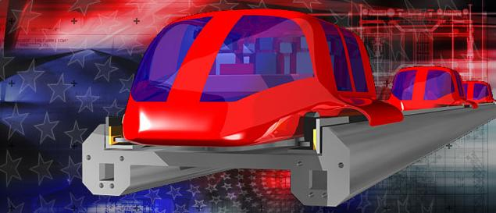

10 Economic Generator
Transportation investment has historically generated multiplier investments in adjacent real estate property. With our existing at grade transportation systems all over loaded, an elevated transportation network is needed. Automated Guideway Transport (AGT) offers the potential to relieve existing systems and cause new growth of pedestrian villages around stations. For each AGT route thousands of development jobs will be created and these could grow into millions as the routes interconnect. This infrastructure can generate the conditions for companies to grow new profits frontiers in tomorrow's economy of innovation. In every state, various industries will be needed to organize, fund, build and operate a variety of AGT transport routes by many venders and technologies that would be stimulated by tens of thousands of jobs to build a countrywide AGT network:

11 Conclusion
We understand what is happening in this industry and demonstrate our vision with our Business Plan. The $12 million to capitalize this development consortium can go a long ways from building a Prototype track, winning a statewide vote, organizing a development consortia and perhaps even optioning land around future station sites for development ventures. Due Diligence
Membership Subscription
SmartSkyways shareholder Agreement PV Economic Feasibility
State Ballot Proposal I-70 Economic Feasibility
DTC Plan and Feasibility Resumes

CIFGA | Xcel | JESPIA
Tourism Board | Fuller | Intrawest
RTD | East West | Qwest
Burlington | Trillium | Vail Assoc.
DOE | Kronke | USBank
Landry | Kiewit | Travelers
CFI | Motorola | Avis

Other Sales Potential

We are currently studying 10 states where we think a demonstration model has the right fit to become economically successful. This map shows them and each one is getting a report under the routes section on our web site. Routes are located under the technology button on the home page. The report for all sites are yet completed.

To: SmartSkyways LLC

I approve of this Business Plan to raise $5 million from a Joint Venture partner as of this 18, day of February, 2003 and specifically of my participation in it as described by my job description and compensation. I agree to promote the business plan and when funding is imminent, I will negotiate an independent contract agreement with SmartSkyways for the job position shown in this plan

By_________________________
SmartSkyways LLC Member

http://www.skyaid.org/Skycar/skycar_PugetSound_Dec28.htm

